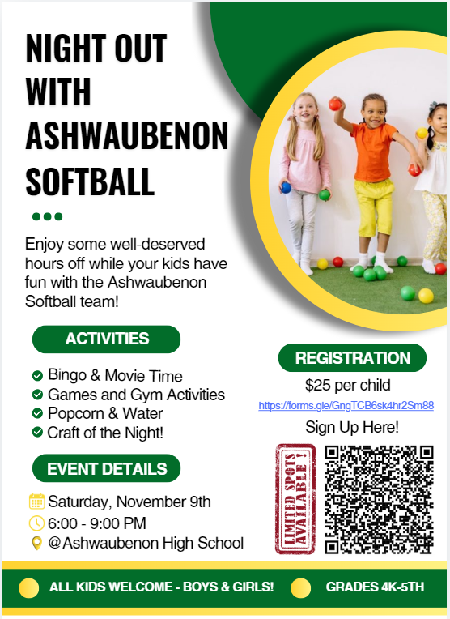
ATTENTION PARENTS!
Need a night off? Let the Ashwaubenon Girls Softball Team take care of the fun! On November 9th, we’re hosting a 'Night Out with Jaguar Softball' for kids in the district. Parents, this is your chance to enjoy a well-deserved evening while our team leads games, activities, and tons of fun for the kids. All kids are welcome – boys and girls!

Sign up now!
Link: https://forms.gle/GngTCB6sk4hr2Sm88
QR Code

